**PREREQUIRMENTS**

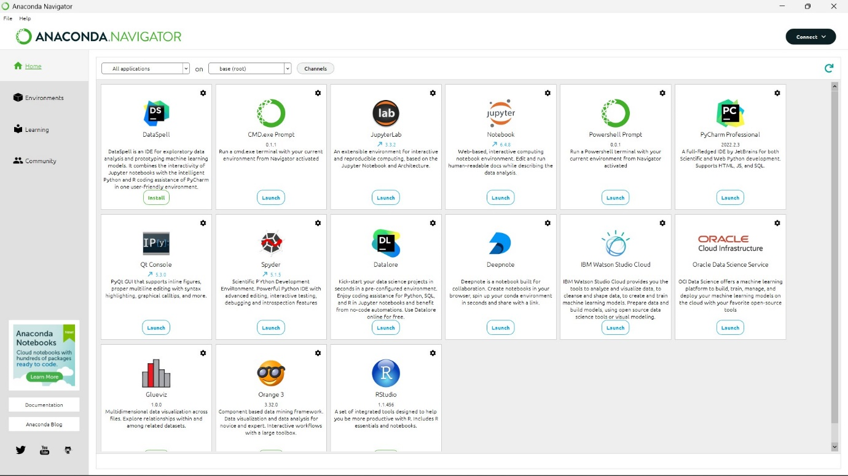**Installation of Anaconda Navigator**

**Installation of TensorFlow**

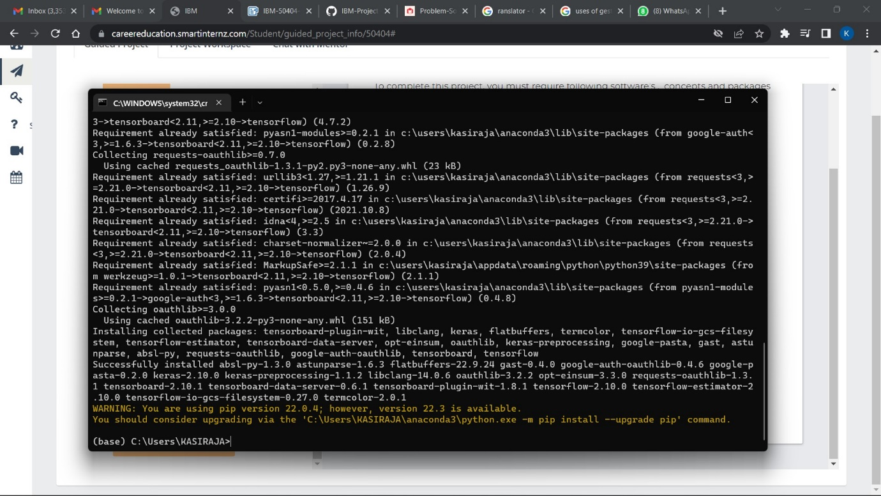

**Installation of Opencv-python**

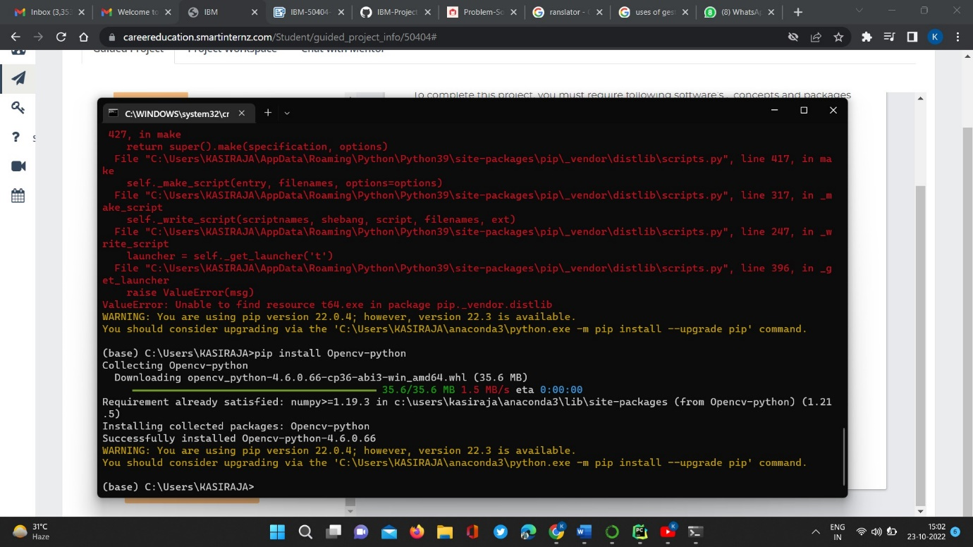

**Installation of flask**

